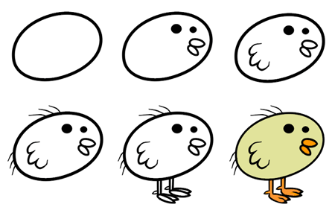
Name:_____
The Osmosis Inquiry
Egg Lab

Introduction: A chicken egg is analogous to a cell. Once you have removed the hard outer shell, water will move across the membrane of the egg based on the principles of osmosis, just as with any other cell. Since the membrane is selectively permeable, some solutes will move across and others will not. The solutes follow the magic rule: solutes move from areas of higher concentration to lower concentration without the use of energy (passive transport).

Procedure: Day 1: Remove the Shells
Place all eggs (carefully) into a container filled with vinegar. Leave for 24 hours and the shell will dissolve. (Your awesome science teachers did this for you)

Procedure: Day 2: Design Day and Collect Initial Data
1. Decide on an experimental question.
2. Formulate a hypothesis and prediction.
3. Design (with words and a sketch) your experiment per directions.
4. Discuss your question and experiment with the teacher and/or other groups for constructive feedback.
5. Collect initial (starting) egg data. Make initial measurements of your own choosing, Think of how many ways you could detect and document evidence of change caused by osmosis.
6. Set up experiment.

Procedure: Day 3: Collect Data
1. Take measurements.
2. Brainstorm on conclusions. Was your hypothesis supported?

Safety Concern:
- Wear goggles
- Wear an apron
- Pull hair back and no baggy clothes
- Wash your hands with soap after touching the eggs.

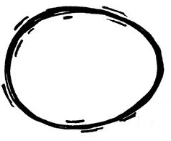
The Osmosis Inquiry Egg Lab Report

Hypothesis: If we add __________________ (liquid name) to the egg solution, then the weight will _______________ (increase/decrease).
Materials: In the space below, list all materials used in this experiment.

Procedure: List out the procedures in 1, 2, 3 manner. Make sure it is legible and comprehensive. Another person should be able to follow these steps without any problems. Make a visual depiction (picture) also.

Quantitive Data:
Solution: | Initial Weight: | Final Weight: | Change over 24 hrs  % change = ((Final mass – initial mass) / initial mass) * 100
 | Initial Mass (g): | Final Mass (g): | Percent Change:
 | Initial Mass (g): | Final Mass (g): | Percent Change:

Qualitative Data: For each solution, draw pictures of what the egg in the beaker looked like before and after the experiment. Please add color and label all drawings.

Conclusion: EACH GROUP MEMBER TO WRITE YOUR OWN CONCLUSION using the prompts below on a separate sheet of paper. Make sure to answer the questions using complete sentences. Refrain (do not use) the word “it.” Discuss the concepts involved. Be sure to define key terms (should be one or two paragraphs). Include these words: hypertonic, hypotonic, isotonic, osmosis, diffusion, passive transport.

- Conclusion: Analyze your data. Some questions to answer:
-Restate briefly what you did.
-What did you observe?
-What does your observations and data mean?
-Are you accepting or rejecting your hypothesis(es)?
Explain using your data (include egg weights).
-Are you observations valid? Any errors?
-What did you learn from this lab? Please, make sure to tie in the knowledge gained in the lab to previous knowledge acquired in the classroom setting.

You will present you findings to the class. You will describe your experiment and tell us your conclusion using your data as evidence for support.

