NAME__________________________________________________________DATE___________________

Review:
- Explain the reasons in which a population that reproduces asexually, such as bacteria, would not be able to survive in a constantly changing environment.

- Explain the reasons in which a population that reproduces sexually, such as butterflies or lillies, would be able to survive in a constantly changing environment.

- Compare the processes of mitosis and meiosis in terms of: types of cells which undergo the process, types of organisms which undergo the process, number of cells produced, number of cell divisions, haploid, diploid, steps, genetic variability of daughter cells, and problems that occur.
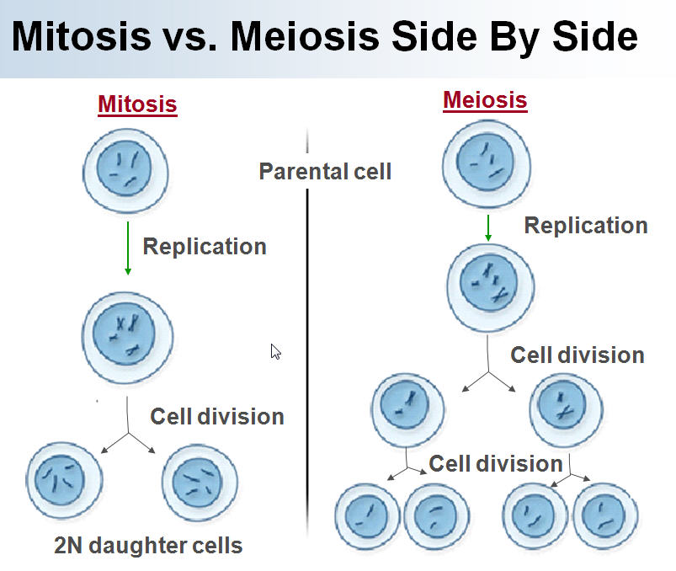

- What stage of interphase is the DNA copied or synthesized?
- Describe how cancer can occur.

- Explain how “crossing over” which occurs in prophase 1 of meiosis increases genetic variation within a population.

- Explain what is meant by nondisjunction.

- What is a karyotype? What is it used for?

- A normal human has _______ chromosomes or ________ pairs of chromosomes. The sex chromosomes are ________ for a female and _________ for a male.

Mendel:
- Who is Mendel?
- What did Mendel research?
- Mendel’s Laws
  - Law of Segregation- b. Law of Independent Assortment-

- Explain how Mendel’s laws relate back to the process of meiosis.

- Explain potential chromosomal mutations:

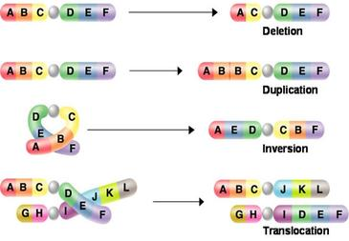
  - Deletion-

  - Duplication-

  - Inversion-

  - Translocation-

Essential Vocabulary and Identification:
1. Define:

Heterozygous-

Homozygous-

Carrier-

Dominant Allele-

Recessive Allele-

For each genotype, indicate whether it is heterozygous (HE) or homozygous (HO)
AA ____  Bb ____  Cc ____  Dd ____ | Ee ____  ff ____  GG ____  HH ____ | Ii ____  Jj ____  kk ____  Ll ____
2. Define:
Phenotype-

Genotype-

For each of the genotypes below, determine the phenotype.
Purple flowers are dominant to white flowers  PP ___________________________  Pp ___________________________  pp ___________________________ | Brown eyes are dominant to blue eyes  BB ___________________________  Bb ___________________________  bb ___________________________
3. For each phenotype, list the genotypes. (Remember to use the letter of the dominant trait)
Straight hair is dominant to curly.  ____________ straight  ____________ straight  ____________ curly | Pointed heads are dominant to round heads.  ____________ pointed  ____________ pointed  ____________ round

Punnett Square Practice - Show all work!
Set up the square for each of the crosses listed below. The trait being studied is round seeds (dominant) and wrinkled seeds (recessive).
Rr x rr |  | What percentage of the offspring will be round? ___________
Rr x Rr |  | What percentage of the offspring will be round? ___________
RR x Rr |  | What percentage of the offspring will be round? ___________

Monohybrid Punnett Square Practice – Show all work!
- A TT (tall) plant is crossed with a tt (short plant). What percentage of the offspring will be tall? ___________

- A Tt plant is crossed with a Tt plant. What percentage of the offspring will be short? ______

- A heterozygous round seeded plant (Rr) is crossed with a homozygous round seeded plant (RR). What percentage of the offspring will be homozygous (RR)? ____________

- A homozygous round seeded plant is crossed with a homozygous wrinkled seeded plant. What are the genotypes of the parents? __________ x __________

- What percentage of the offspring will also be homozygous? ______________

- In pea plants purple flowers are dominant to white flowers. If two white flowered plants are cross, what percentage of their offspring will be white flowered? ______________

- A white flowered plant is crossed with a plant that is heterozygous for the trait. What percentage of the
offspring will have purple flowers? _____________

Dihybrid Punnett Square Notes:
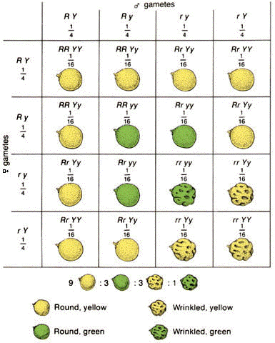
How many of the following are present?
Round, yellow____ Round, green_____
Wrinkled, yellow____ Wrinkled, green_____
How many out of 16 have round shape and green color? ____
How many out of 16 have wrinkled shape and yellow color? _____

Co-dominant and Incomplete dominant traits – Punnett Square Practice
Define:
Co-dominant traits-

Incomplete dominant traits-

For the following examples:
First - Indicate whether each of the following examples is a co-dominant trait or incomplete dominate trait.
Second – Write the genotypes for the traits
a) Birds can be blue, white, or white with blue-tipped feathers.
Answer: Co-dominant Blue feather: BB White feathers: WW White with blue tips: BW
b) Flowers can be white, pink, or red.

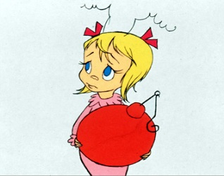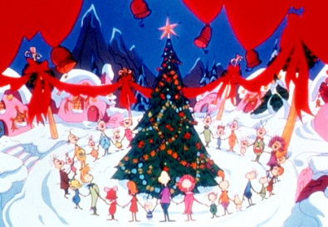
c) A Hoo from Whoville can have curly hair, spiked hair, or a mix of both curly and spiked.

d) A Hoo can be tall, medium, or short.

e) Dogs in Whoville can be spotted, black, or white.

In Smileys, eye shape can be starred, circular, or a circle with a star. Write the genotypes for the pictured phenotypes.

1. Show the cross between a star-eyed and a circle eyed.
What are the phenotypes of the offspring? ____________
What are the genotypes? __________

Extra Credit
2. Show the cross between a circle-star eyed, and a circle eyed.
How many of the offspring are circle-eyed? ____________
How many of the offspring are circle-star eyed? __________

3. Show the cross between two circle-star eyed.
How many of the offspring are circle-eyed? ____________
How many of the offspring are circle-star eyed? __________
How many are star eyed? ____________

Sex-Linked Punnett Square Practice – Hint: Similar to monohybrid punnett squares except you have to use the X and Y chromosomes as well X^{T}X^{t}, X^{T}Y (x-linked) or XX, XY^{H} (y-linked).

- Colorblindness is inherited as a sex-linked recessive disease. An affected male marries a heterozygous female. Draw a Punnett square of the possible offspring. What is the chance that they will have an affected child? Could any of their daughters be affected? Why are males more likely affected?

- Hairy ears are inherited as a Y-linked trait. A man with hairy ears marries a woman with normal ears. Draw a Punnett square of the possible offspring. Could any of their children have hairy ears?

- Fragile X syndrome is inherited as sex-linked dominant disease on the X chromosome. Fragile X Syndrome (FXS) is the most common inherited form of mental retardation. Symptoms, which are typically milder in females than in males, include behavioral and/or emotional problems (including autistic-like features) and varying degrees of mental impairment. Some affected males also have subtle physical abnormalities. An affected female marries a man who does not carry the trait. Draw a Punnett square of the possible offspring. What is the likelihood that any child they have will be affected. What would the genotypes of the mothers parents most likely have been(grandparents of these offspring)?

