NAME(s)_____________________________________________________________DATE_________________
Microscope Lab
Purpose: Students should be able to properly use a compound light microscope to identify micro-organisms.

Pre-lab Questions:
1. What type of lab injury would you predict is the most common in an activity like this? What can you do to ensure you do not get injured? What do you do if you see broken glass?

2. Compare and Contrast Prokaryotes and Eukaryotes using the following table:
 | Prokaryotes | Eukaryotes
Number of Cells

List of All Organelles Present
Nucleus Present or Not

Type of Reproduction

Movement (cilia, flagella, etc.)
Examples

2. Explain how a compound light microscope is different from an electron microscope.

Part 1: Becoming Familiar with the Compound Light Microscope

Parts of a microscope:
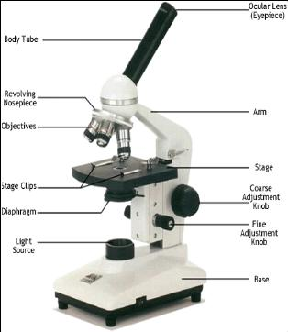
Directions for Use:
- Plug microscope in and turn on the light
- Turn the objective lens to the lowest power (red lens, 4x)
- Use the course adjustment knob to lower the stage as far as you can
- Grab a tri-color cross fiber slide
- Hold the slide up towards the light to get a visual on where on the slide the specimen may be located.
- Place the slide and the stage so that the area where the specimen is located is in the center of the hole on the stage that allows light through
- Look through the ocular eyepiece
- Slowly raise the course adjustment knob until you can see the specimen on the slide
- Use the fine adjustment knob to clarify specimen
- For continued magnification move the objective lens to 10x (yellow).
- Use the fine adjustment knob to clarify, if you need to you can slightly move the course adjustment knob
- For continued magnification move the objective lens to 40x (blue).
- ONLY use the fine adjustment knob
Part 2: Specimen Observations and Questions

- Paramecium
  - Diagram of specimen

  - Magnification you observed specimen
__ x objective lens X 10x ocular =
___ total magnification
  - Is this organism a prokaryote or eukaryote? ____________________ Reasoning?__________________________________________________________
  - Mode of locomotion ______________________________

- Mixed Green Algae
  - Diagram of specimen

  - Magnification you observed specimen
__ x objective lens X 10x ocular =
___ total magnification
  - Is this organism a prokaryote or eukaryote? ____________________ Reasoning?__________________________________________________________
  - Mode of locomotion ______________________________

- Diatom
  - Diagram of specimen

  - Magnification you observed specimen
__ x objective lens X 10x ocular =
___ total magnification
  - Is this organism a prokaryote or eukaryote? ____________________ Reasoning?__________________________________________________________
  - Mode of locomotion ______________________________

- Specimen of your choice ______________________________
  - Diagram of specimen

  - Magnification you observed specimen
__ x objective lens X 10x ocular =
___ total magnification
  - Is this organism a prokaryote or eukaryote? ____________________ Reasoning?__________________________________________________________
  - Mode of locomotion ______________________________

Analysis Questions:
1. What was your favorite organism to observe? Why?
2. Which kingdom do paramecium, algae and diatom belong to?
3. Describe the characteristics of this kingdom?
4. What are the three main types of organisms classified within this kingdom? Compare and contrast them to each other.
5. How would you explain the biodiversity of this kingdom to someone unfamiliar with living things. Use specific examples that ordinary people could relate to.

