Research Question: How can I use an organism's genetic make-up and gel electrophoresis to assemble a phylogenetic tree?

Background: Gel Electrophoresis is used to separate DNA fragments using an electric field. DNA is negatively charged, and electrophoresis is used by scientists to differentiate DNA fragments in a sample by size. To do electrophoresis, you need a specialized agarose gel that the DNA can run through. Depending on the amount of agarose in it, the structure of the gel can catch different-sized DNA fragments. The gels that you will be using are 1% agarose gels, which are used to catch larger-sized DNA pieces. The gels are loaded with DNA and are placed in a solution in an electrophoresis chamber. Then, an electric current is run through the chamber, which attracts the DNA down the gel until it is caught in the matrix. Throughout this process, smaller DNA fragments have an easier time flowing through the gel, thereby traveling further along the gel. This process creates what appears to be bands depicting the size of DNA fragments, and how much DNA is within those bands.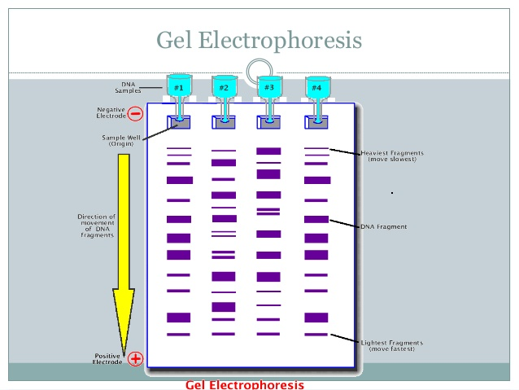

A cladogram is a diagram used to represent a hypothetical relationship between groups of animals, called a phylogeny. A cladogram is used by scientists studying phylogenics to visualize the groups of organisms being compared, how they are related, and their most common ancestors. A cladogram starts with a common trait, then progressively adds traits that are more and more specific to a species, illustrating which species are more related and how.
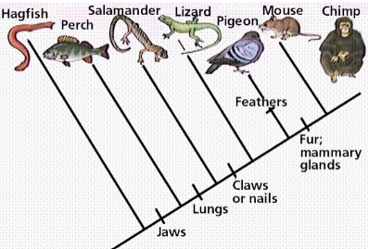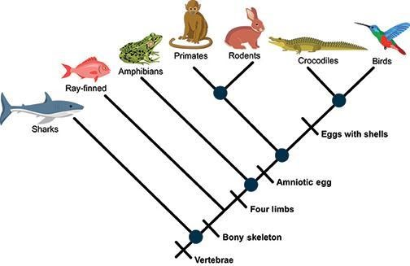
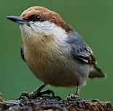
You will be given the DNA samples of five bird species. Your goal is to determine which birds are most closely related based on the similarities in their DNA fragments that result from running gel electrophoresis.
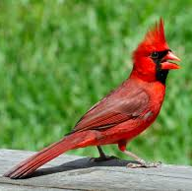
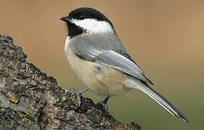
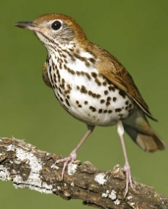
Make a claim.
Which species (1-5 from above left to right) do you think are most closely related and/or which do you think are least closely related?
_______________________________________________________________________________________________________________________________________________________________________________________________________________________________________
Evidence and Data
Record the species sample number by each corresponding well in the gel diagram below.
After the electrophoresis process is finished running, draw the results on this same gel.
As a group discuss which DNA samples were similar and which were different. Complete table 1 below. Table 1 depicts which species have which color/gene. Use a + symbol if the gene is present and a – symbol if it is absent.
Construct a cladogram, similar to the images in the background, that show the relationships of these 5 organisms.
Cladogram- draw in the box below.

Table 1. Presence (+) or absence (-) of genes in each of our five bird species.
DNA Fragment | Species 1 | Species 2 | Species 3 | Species 4 | Species 5
Yellow gene
Blue gene
Orange gene
Salmon gene
Purple gene

Reasoning
Some questions and topics to consider when writing your reasoning are:
- Explain, using specific data from your gel, how the results compare to your claim.
- Explain, in detail, why your cladogram was labeled the way it is.
- In what ways were you surprised at the visual (phenotypic similarities) and the actual genotypic results?
- Which sample had the least amount of DNA in common? Which samples had the most in common? What does that mean in terms of evolutionary relationships?
- Where any samples the same? What do you think that means?
- As a group, did you have any difficulty? Why?
- Why is DNA one of the best tools to use to compare organism’s genetic similarities or differences?
- Would you do anything different next time? What could you do with the two samples that were identical to see if in fact, they were the same species or just very closely related?
______________________________________________________________________________________________________________________________________________________________________________________________________________________________________________________________________________________________________________________________________________________________________________________________________________________________________________________________________________
____________________________________________________________________________________________________________________________________________________________________________________________________________________________________________________________________________________________________________________________________________________________________________________________________________________________________________________________________________________________________________________________________________________________________________________________________________________________________________________________________________________________________________________________________________________________________________________________________________________________________________________________________________________________________________________________________________________________________________________________________________________________________________________________________________________________________________________________________________________________________________________________________________________________________________________________________________________________________________________________________________________________________________________________________________________________________________________________________________________________________________________________________________________________________________________________________________________________________________________________________________________________________________________________________________________________________________________________________________________________________________________________________________________________________________________________________________________________________________________________________________________________________________________________________________________________________________________________________________________________________________________________________________________________________________________________________________________________

