NAMES:_______________________________________
Photosynthesis Lab - Elodea and Bromothymol Blue
SB3 Students will derive the relationship between single-celled and multi-celled organisms and the increasing complexity of systems.
- Explain the cycling of energy through the processes of photosynthesis and respiration.
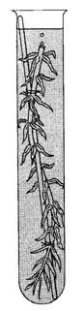
Background Information: Green plants use sunlight to make glucose. To do so, the plant must use carbon dioxide and water in a process called photosynthesis. The glucose made by plants is used by plants and animals as a source of energy. To release the energy contained in the bonds of glucose, the glucose must be converted to ATP. The process by which ATP is made from glucose is called cellular respiration. Respiration also produces waste products including carbon dioxide and water, which are the same substances that served as raw materials for photosynthesis. In water, carbon dioxide dissolves to form a weak acid. As a result, an acid-base indicator such as bromothymol blue (btb) can be used to indicate the presence of carbon dioxide. In this lab, you will use bromothymol blue as an indicator to show how much CO₂ is left in test tubes containing plants exposed to light. Elodea is a freshwater aquatic plant native to the United States. Commonly known as the waterweed, elodea is an important component of aquatic ecosystems. A small piece of elodea will be introduced to a solution containing bromothymol blue and CO₂. The purpose of this lab is to determine the effects of elodea on CO₂ levels and to observe evidence of cellular respiration and photosynthesis.

Equation: Write out the balanced equation for photosynthesis
___________________________________________________
Equation: Write out the balanced equation for cellular respiration
___________________________________________________
Materials:
Ruler
Scissors
Masking Tape
Aluminum Foil
Sharpie
Erlenmeyer Flask with Bromothymol blue solution (the solution already has been infused with CO₂)
Graduated Cylinder
4 test tubes and Red test tube holder
Beaker with Elodea (cut three segments: 7cm, 15cm, 15cm)

Procedures:
1. Pour the CO₂ induced Bromothymol blue solution in each test tube and FILL TO THE TOP.
2. Label four test tubes with the following: "Control," "7 cm Elodea," "15 cm Elodea" And "15 cm dark.” Add your initials to each test tube.
3. The test tube marked "Control" is sealed with masking tape. Do not put an elodea plant in the “control” test tube.
4. Measure and cut the Elodea into the following lengths: 7cm, 15cm, 15cm.
5. Take the initial pH of each test tube and record your data in the table below. Using colored pencils try to simulate, as accurately as possible, the initial color of the solution in the test tubes.
6. Place the Elodea pieces into the corresponding test tubes (see diagram at end of procedures). Use the tape to completely seal all 4 test tubes so no gas escapes.
7. Wrap the "15 cm dark" test tube in aluminum foil, so that no light gets in.
8. Place test tubes in the rack and place the rack underneath the white hanging lamps.
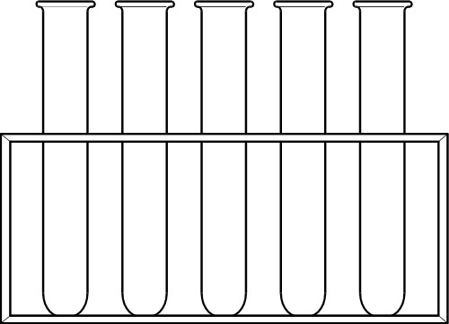
9. View the colors and pH of the test tubes after a 24 hour period of time. Observe the color differences after 48 hours. Record your observations in the data table.
Control 7cm 15cm 15cm dark

FILL Test tube to the top

Seal with STOPPER
wrapped
in foil

Results: Color description for each test tube.
Sample | Control | 7 cm Elodea | 15 cm Elodea | 15 cm Dark
Color (initial)

Color (24 hours)
Color (48 hours)
pH (initial)
pH (24 hours)
pH (48 hours)
Hypothesis: Predict what you think will happen to the color of each test tube.

Questions to answer after your lab is set-up and your initial data is recorded.
Photosynthesis requires light energy to proceed, but most plants are not in the sun 24 hours
a day. What reactions are taking place during the night? Consider the following experiment
to help you answer the questions below: You have two sealed boxes. One is clear with a
light source shining into it, and the other is completely dark. In each box is placed a healthy,
genetically identical plant with no known disorders or diseases. Both plants have access to
adequate water and nutrients. At the end of one week, both plants are still alive, but one
is clearly doing better than the other.

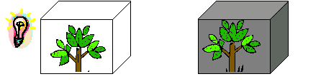
1. What inputs are required for photosynthesis? 7. Which gasses will increase in each box?
2. What inputs are required for cellular respiration? 8. Which gasses will decrease in each box?
3. What are the outputs of photosynthesis? 9. In which box is the Calvin Cycle taking place?
4. What are the outputs of cellular respiration? 10. What is the independent variable? Dependent?
5. After one week in the box, which plant will be healthier? Why? 11. What are 3 controlled variables?
6. Why are BOTH plants still alive?
Intro to Photosynthesis Lab

Predictions: Based on any prior knowledge you have of photosynthesis predict which factors listed below will be higher or lower for the elodea in the dark or exposed to light. Write your predictions in the space provided below.

Table 1. Differences in abiotic factors for different environments
 | Dissolved Oxygen | pH | Temperature
Elodea – Light
Elodea – Dark
- Did the plants alter the level of CO₂ in the beakers?
2. What abiotic factors were different between the two beakers? Write what the differences were using your actual data.

3. What is the purpose of the control? Which beaker would you use as the control?

4. Write the chemical equations for both cellular respiration and photosynthesis. Describe how these two processes could be considered “mirror images” of one another.

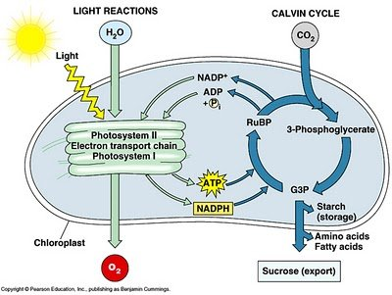
5. Examine the schematic diagram to the right.
Write a short paragraph that explains the process
Of photosynthesis and differentiates between
the light dependent and light independent cycles.

