NAME_____________________________
REPLICATION, TRANSCRIPTION, TRANSLATION…oops! MUTATION
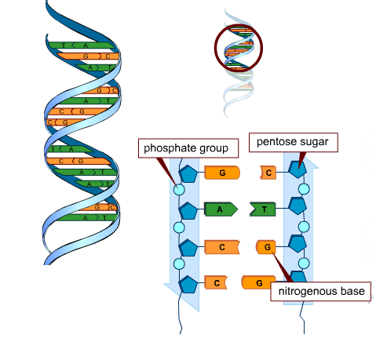
SB2 Students will analyze how biological traits are passes on to successive generations.
- Distinguish between DNA and RNA.
- Explain the role of DNA in storing and transmitting cellular information
- Describe the relationships between changes in DNA and potential appearance of new trails.

Nucleotides:
- Draw the structure of a nucleotide
- What polymer do nucleotides make up?
- List which nucleotides are Purines. Which are Pyrimidines.

DNA vs. RNA
Nucleic Acid | Structure | Location | Composition (Sugar)

Replication
- Where does replication take place?
- List the steps of replication.
- Name the enzyme that builds the new DNA strand
- How many Hydrogen bonds hold Adenine to Thymine? Guanine to Cytosine?

Transcription
- Where does transcription take place?
- List the steps of replication.
- Name the enzyme that builds the new RNA strand.
- What nucleotide is replaced during this process?

Translation
- Where does translation take place?
- What does translation produce?
- List the steps of translation.
- Explain the name and purpose for each of the following types of RNA
  - mRNA
  - rRNA
  - tRNA
- How many nucleotides are in a codon?
- How many codons are used to determine an amino acid?
Label each of the structures (A-G) in the picture below.
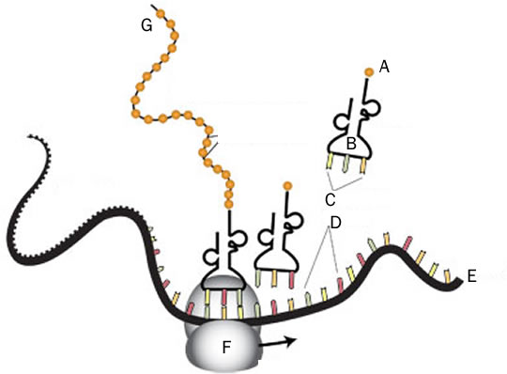

Coding
Write the mRNA, tRNA, and amino acids from the DNA strand
DNA TAC AAT CGC GAT TCG AGG ACT TCG ATT
mRNA
tRNA
Amino Acid
Identify each of the following mutations based on the original strand
Original Strand
TACATTGCATCGCCATUGA
Mutated Strands

TACATTCATCGCCATUGA

TACATTGCATCACCATUGA

TACATTTGCATCGCCATUGA

- How can mutagens affect your DNA?
- List common mutagens that can be found on Earth.

