NAME______________________________________________________DATE_______________________

SB2 Students will analyze how biological traits are passed on to successive generations
- Distinguish between DNA and RNA
Complete these notes using the honors biology text book.

Review:
- Fill in the table below
 | Monomer | Functions | Organelle Association
Nucleic Acid
Protein (polypeptide)

- DNA and RNA are the genetic _____________________ for making proteins. Ribosomes link _________ ___________ in the correct order to form ________________, such as your hair and eye color.

DNA – Textbook concept 11.2
- Draw and label the three parts of a nucleotide.

- Complete the following information for DNA
  - The scientists given credit for the model of DNA are _______________________ and ____________________.
  - DNA stands for __________________________________________.

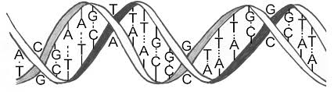
  - The shape of DNA is known as a ___________.
  - The “backbone” or sides of the double helix are the ______________________ and ________________. The center of the double helix, or the steps of the twisted ladder are the _________________________.
  - The sugar located in the nucleotide of DNA is _________________________________________.
  - The four possible nitrogen bases for a DNA nucleotide are: ____________________ _________________ _________________ and ________________________.

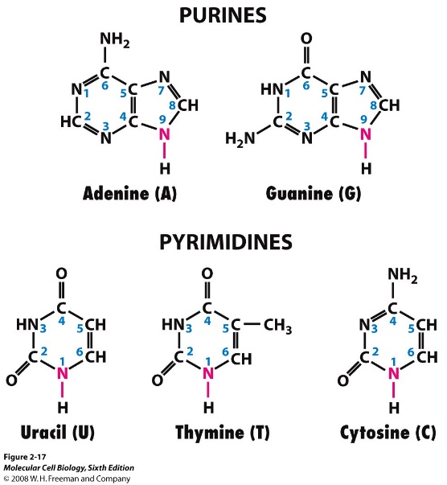
  - Thymine and Cytosine are considered _________________________ while Adenine and Guanine are classified as _________________________.
  - Evaluate the table below:
Percentages of DNA Nucleotides in Selected Organisms
Source of DNA | Adenine (A) | Cytosine (C) | Guanine (G) | Thymine (T)
Human | 30.2 | 18.8 | 18.8 | 32.2
Rat | 28.6 | 21.6 | 21.4 | 28.4
Sea Urchin | 31.2 | 19.1 | 19.2 | 30.5
Salmon | 29.2 | 20.8 | 21.9 | 28.1

  - Based on the information above and what you have read, you can conclude that the complementary base pair rules indicated that adenine pairs with _____________ and guanine pairs with ___________________. This also means that a pyrimidine always pairs with a ________________.
  - If one side of the double helix is: 5’ATC GGC ATA GTA ATT CGG 3’
Then its complimentary DNA base pairs are:
- Complete the DNA/RNA comparison table below ( you will need to look past concept 11.2):
 | DNA | RNA
Full Name
Monomer
Location(s) within a eukaryote
Shape (double helix or single strand)
Sugar
Nitrogen bases

- What are the three types of RNA found in cells? __________________ , _______________ and ____________________.
- Making a Protein…
  - DNA _________ __________________
  - The steps required to make a protein are
    - _________________________ - DNA is copied (this is not technically part of protein synthesis)
    - _________________________ - RNA is made from DNA
    - _________________________ - Protein is made from RNA

