APES Guided Notes NAME____________________________
Chapter 8 – Earth Systems
Standard 4

Module 24 – Mineral Resources and Geology
- Read the Case Study: Are Hybrid Electric Vehicles as Environmentally Friendly as We Think?
- What are the environmental issues associated with HEV’s?
- Conclusion – traditional cars or HEV…which is better and why?
- Deep History of Life on Earth – Click and learn. Link on website
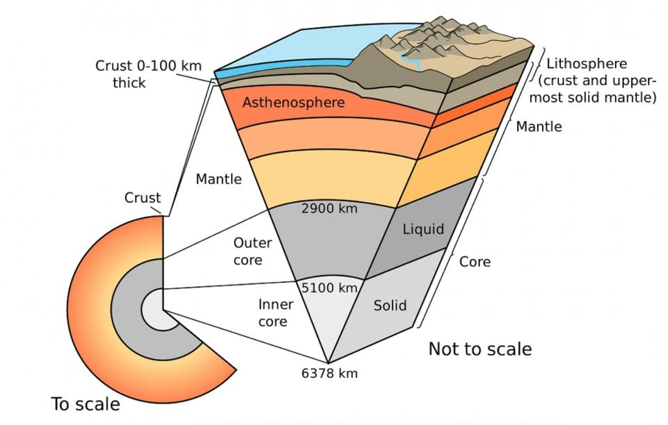
- Earths Layers and their composition
- Core-
- Mantle-
- Asthenosphere-
- Lithosphere-
- What is the theory of plate tectonics?
- What evidence is there to support the theory?
- Using figure 24.5 to determine where the formation of the following occur:
- Formation of oceanic crust-
- Volcanic activity-
- Formation of mountain ranges-
- Increased seismic activity-
- Describe each type of boundary and give a likely outcome result from the type if plate contact.
Continental Crust meets oceanic crust-
Divergent Boundaries-

Oceanic crust meets oceanic crust-
Convergent Boundaries-
Zones of plate Contact

Continental Crust meets continental crust-
Transform Fault Boundaries-

- The Ring of Fire --- Not just a Johnny Cash Song
- Describe a subduction zone and how this leads to volcanic activity
- Describe primary succession and soil formation from volcanic rock
- Explain how tsunamis form as a result of plate movement
- Describe transform boundaries as an earthquake occurs and after the earthquake has occurred
- Describe an ecological, an environmental, as social, and an economic impact associated with plate movement.
- Summarize the rock cycle.
- Complete the following table on the subject of the rock formation
 | Igneous | Sedimentary | Metamorphic
Formation
Types
Unique Characteristics

- Answer the module 24 review questions:
- Answer the Module 25 review questions:
- ______
- ______
- ______
- ______
- ______
- ______

Module 25 – Weathering and Soil Science
- Distinguish between chemical and physical weathering. Give examples of each type of weathering.
- Physical –
- Chemical-
- What are environmental benefits of weathering?
- Describe each factor and how it contributes to soil properties:
Parent Material
Climate
Topography
Organisms
Time

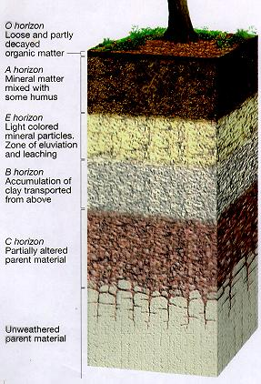
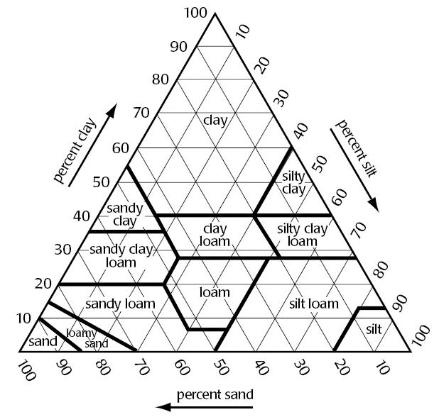
- How do nutrient values change with time (refer to figure 25.5)?
- How have humans contributed to soil degradation?
- What is humus and where is it found in the soil profile?
- Describe the properties of soil below.
- Physical Properties
- Texture
- Permeability
- Chemical Properties
- Cation exchange
- Base saturation
- Biological Properties
- microorganisms
- detritivores
- Which type of soil is best for
- Agriculture
- Contaminant of pollution
- Supporting high productivity in a soil
- Using table 25.1 on page 283 predict some potential economic consequences the USA might face because of unequal distribution of metal reserves?
- Complete the mining table below.
Type of mining operations | Description | Effects on air, water, soil, biodiversity and humans
Strip Mining
Open-pit Mining
Mountaintop Removal
Placer Mining
Subsurface Mining

- Describe the following pieces of legislation (what it entailed, what led to the legislation, and what the outcomes were):
  - Mining act of 1872
  - Soil Conservation Act of 1935
  - Comprehensive Environmental Response, Compensation and Liability Act of 1980 (CERCLA or Superfund)
- Answer the Module 25 review questions:
- ______
- ______
- ______
- ______
- ______
- ______

