AP Environmental NAME________________________________
Chapter 15 Guided Notes

Module 14 Biodiversity (PowerPoint slides)
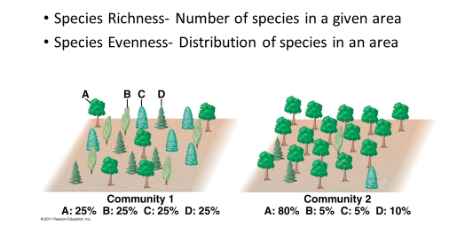
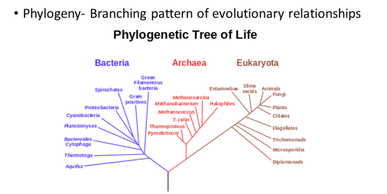

MATH TIME ( page 152):

Review Questions: 1. ____________ 2. ____________ 3. _____________ 4._____________

APES Module 15 Evolution
Vocabulary
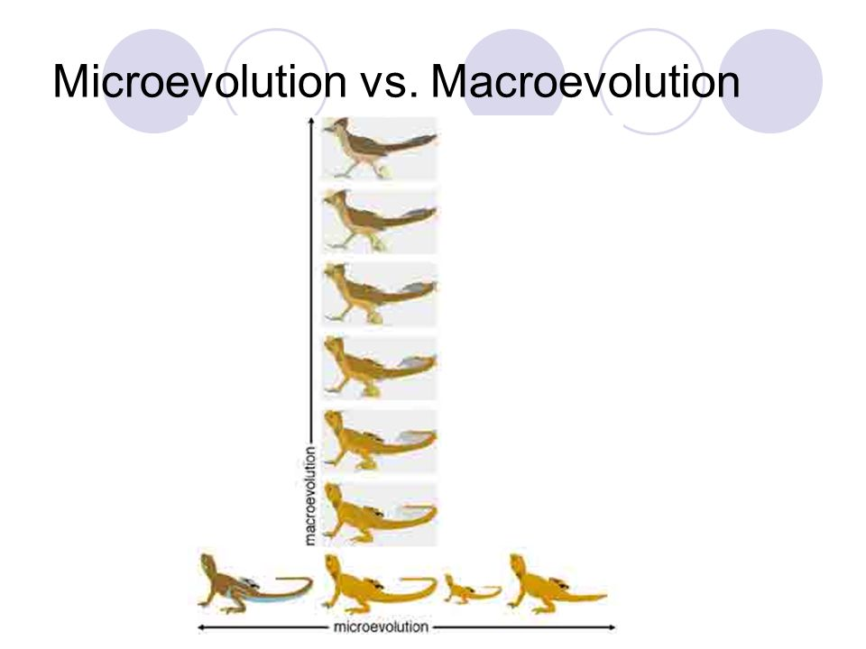
- Biodiversity is the product of evolution
- Evolution: A change in the genetic composition of a population over time
- Microevolution: Evolution below the species level
- Macroevolution: Evolution above the species level that leads to a genera, phyla, etc.
- Speciation: Creation of a new species
- Gene: A physical location on a chromosome that codes for a specific protein
- Genotype: Complete set of an individual’s genes (Mostly analyzed via pedigrees and Punnett squares)
- Phenotype: Set of traits expressed by an individual as a result of its genotype and/or the surrounding environment
- Mutation: Random change in the genetic code produced by a mistake in the DNA replication process
- Recombination: The process by which one chromosome breaks off and attaches to another chromosome during reproductive cell division
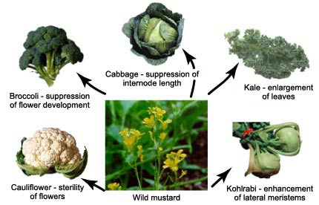
- Evolution by artificial selection: The process in which humans determine which individuals breed, typically with a preconceived set of traits in mind (Eugenics, Selective Breeding, Artificial Insemination)
- Evolution by natural selection: The process by which nature determines which individuals survive and reproduce
- Fitness: An individual’s ability to survive and reproduce
- Adaptation: A trait that improves an individual’s fitness
- Gene Flow: The process by which individuals move from one composition of both populations
- Genetic drift: A change in the genetic composition of a population over time as a result of random mating
- Bottleneck effect: A reduction in the genetic diversity of a population caused by a reduction in its size
- Extinction: Death of last member of a species
- Founder effect: A change in the genetic composition of a population as a result of descending from a small number of colonizing individuals

Review Questions: 1. _______ 2. ________ 3. _______ 4.______ 5. _______ 6. ________ 7. _______

APES Module 16 Speciation and the Pace of Evolution

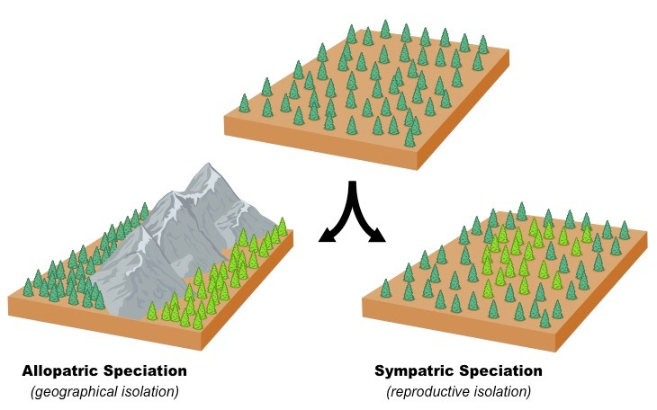
Vocabulary:
Geographic isolation-
Allopatric speciation-
Reproductive isolation-
Sympatric speciation-
GMO-

Debate the Issue:
Do the potential benefits of genetically modified organisms outweigh the unknown consequences and potential dangers?

Review Questions: 1. _______ 2. ________ 3. _______ 4.______

APES Module 17 Evolution of Niches and Species Distributions
Key Terms:
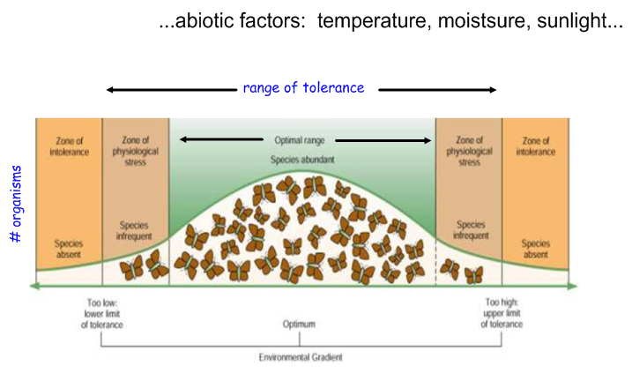
- Range of Tolerance: The limits to the abiotic conditions that a species can tolerate.
- Fundamental Niche: The suite of abiotic conditions under which a species can grow, survive, and reproduce.
- Realized Niche: The range of abiotic and biotic conditions under which a species actually lives.
- Distribution: Areas of the world in which a species lives.
- Niche Generalist: A species that can live under a wide range of abiotic or biotic conditions.
- Niche Specialist: A species that is specialized to live in a specific habitat or to feed on a small group of species.
- Mass Extinction: A large extinction of species in a relatively short amount of time.

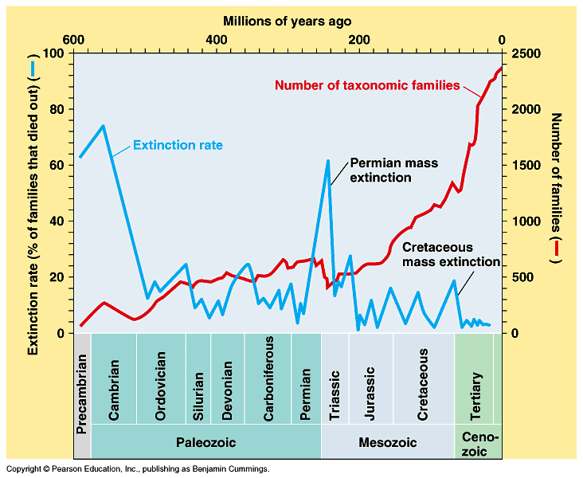
Key points
- Examples of range of tolerance are temperature, humidity, salinity, and pH.
  - Figure 17.1 illustrates range of tolerance with temperatures.
- Environmental change can cause species extinction.
  - There have been 5 Global mass extinctions.
- Scientists believe that we are currently in a 6th mass extinction.
  - Between 5-25% of species are going extinct by 2020
- Fossil records have been used to study evolution and extinctions.

Review Questions: 1. _______ 2. ________ 3. _______ 4.______ 5. _______

Protecting the Oceans When They Cannot Be Bought
Read the case study and answer the TWO critical thinking questions on page 175.

ANSWER ALL Practice Test Questions
p. 177-182

