Define Cellular Respiration:

Balanced Equation:

STAGE | LOCATION | DESCRIPTION | NET ATP PRODUCED
GYCOLOSIS
KREB'S CYCLE
ELECTRON TRANSPORT CHAIN

Fill in the diagram below using the image from your text book on page 148. Write the name of the stage and where in the cell it takes place
Stage 1: cytoplasm of a cell
Stage 2: mitochondria of a cell
Stage 3: mitochondria of a cell

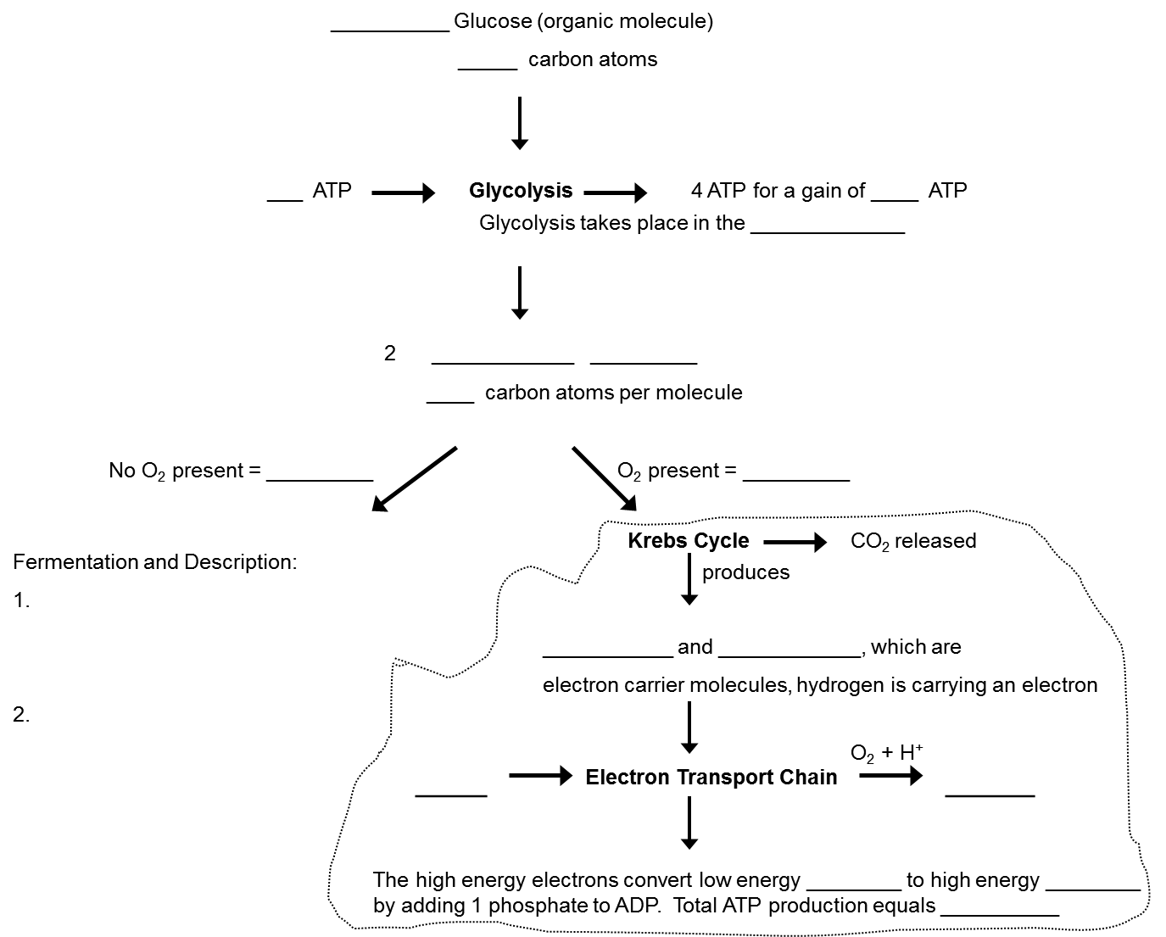
Compare and Contrast table for Photosynthesis and Cellular Respiration
 | Photosynthesis | Cellular Respiration
Who (what kind of organisms preform each process?)
What (what is the BALANCED equation?)
What are the reactants and products? Circle the reactants and draw a line under the products.
When will this process occur?
Where (what organelle(s))
Why do organisms use each of these process?
How (what are the processes or reactions involved)

Answer the following questions.
- How is energy cycled within photosynthesis?
- How is energy cycled within cellular respiration?
- Explain in words and a diagram how these two processes form a cycle.
- How is energy cycled between these two processes?
- Draw the picture of ADP and ATP

