Population Genetics – Genetic Drift & the Bottleneck Effect

INTRODUCTION

Genetic drift is a change in allele frequencies in small populations that appears to occur as a consequence of random chance. It’s like flipping a coin ten times and getting 8 heads and only 2 tails. You believe from your understanding of probability that if you flip the coin often enough, you will ultimately get heads and tails each with a frequency of 0.5 (or 50%) for all flips considered together. The problem with small populations is that they can only produce a limited number of offspring in each generation, and therefore may not produce the expected proportion of a particular genotype in a given generation. Unlike the coin flip example, the parent population can’t go back to the gene pool and have some more offspring until they get the expected proportions right. A consequence of this may be what is known as genetic fixation of an allele, wherein all forms of an allele but one are lost purely by chance within the population.
Genetic drift becomes a factor for evolution in populations that are formed from a small sample of a larger population by either the bottleneck effect or the founder effect. Genetic drift is a change in the relative frequency of an allele due to random fluctuation in an isolated population.

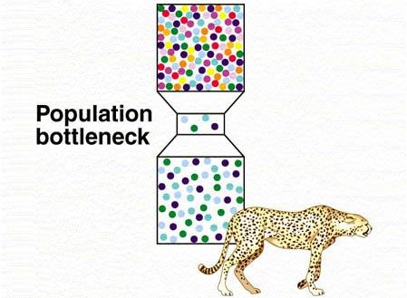

The bottleneck effect occurs when a population passes through a period in which most of the population is killed by natural disaster, disease, or excessive predator pressure. The limited genetic variability seen in the world’s cheetah population is attributed to the bottleneck effect of disease, habitat destruction, and overhunting by humans.

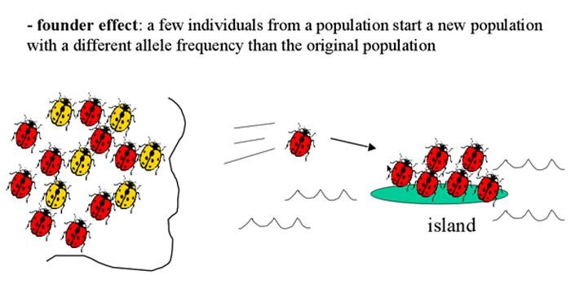
The founder effect occurs when a small portion of the population is transplanted to a new geographic locale. This fragment of the original population establishes its own niche in the new territory. Because the founder population doesn’t represent the genetic diversity of the parent population, it becomes genetically different from the parent population.
A prime example of the founder effect in humans occurs in the northeastern United
States within the Old Order Amish Sect. This population was established by approximately 200 migrants from Switzerland and Germany beginning in the early 18th century. Amish church membership begins with baptism (usually between the ages of 16 and 25). Once a person has affiliated with the church, he or she may only marry within the faith. Members who do not conform to the expectations of the church are excommunicated and shunned. This traditional requirement forbidding marriage outside of the sect has formed a closed genetic unit.

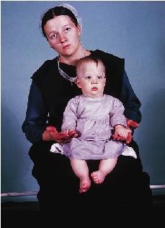
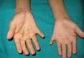
From the small founder population of immigrants, it is estimated that the Amish population living in Canada and the United States has grown to ¼ million. Due to their intermarriage (resulting in a degree of inbreeding), some Amish groups have increased incidences of certain genetic disorders, including dwarfism (Ellis-van Creveld syndrome) and various metabolic disorders. Some of these disorders are quite rare and are serious enough to increase the mortality rate among Amish children.

The majority of Amish accept these conditions as “Gottes Wille” (God’s will); they reject the use of preventative genetic tests prior to marriage and genetic testing of unborn children to discover genetic disorders. However, the Amish are willing to participate in studies of genetic diseases and their contributions have furthered our understanding of the inheritance of numerous diseases.

Watch this brief news clip about the Amish:
http://www.cbsnews.com/video/watch/?id=700552n&tag=contentBody;storyMediaBox

Let us now investigate what will be the effect on allele frequencies that results by subjecting a population either to the bottleneck or founder effect.

PROCEDURE

- Using your beads and containers, establish a gene pool of 100 alleles in which the frequency of each allele will be 0.5. (In other words, add 50 of one color beads and 50 of another color beads to your cup.)
- Remove 8 pairs of alleles to establish the allele frequencies of the bottleneck or founder population. These are organisms in the existing population, not members of the next generation.
- Use these eight individuals to establish the gene pool for the next generation. Prepare a container with 100 beads in the same frequency proportions. This is your gene pool for the next generation.
- Mix the beads well and pick 8 pairs of alleles again as in step 2. The founder or bottleneck population is practicing replacement reproduction, i.e., having two offspring for each mating pair. Using these 8 pairs, establish a container of 100 beads with the allele frequencies that occurred in the 8 pairs to form the gene pool for the next generation of 8 offspring.
- Continue this activity until one allele becomes fixed in the population (only one color is drawn) or you reach the 9th generation. Record your results in the table on the next page.
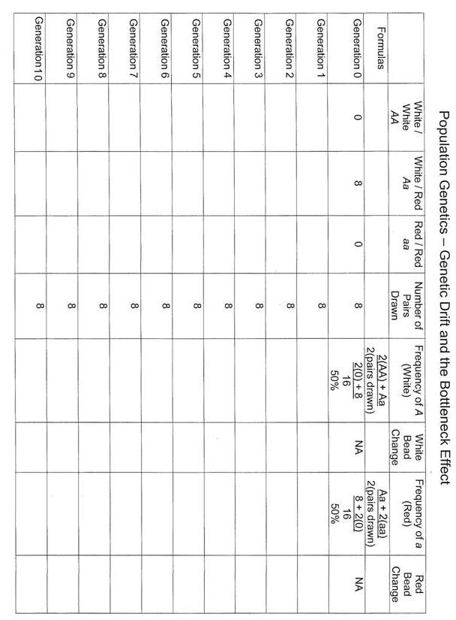

DISCUSSION OF THE RESULTS

- In what generation did one of the two alleles become fixed? _____________ If you did not achieve allele fixation in nine generations, what was the lowest frequency that one allele reached? ___________

- Graph the change in frequencies of the two alleles over time on the graph paper provided.
  - Did the same allele go to fixation for every group in the class?

- Based on the experimental design, why should either allele have an equal opportunity to go to fixation?

- Did all the graphs in the class look the same? _____ If they did not, why didn’t they?

- What would you expect the pattern to look like with an initial population was 25?

- What would you expect the pattern to look like with an initial population was 1000?

